Qatar University
College of Engineering
Dept. of Computer Science & Eng.
Lab 5 Use Case Diagrams

Software Engineering
CMPS 310 - Lab

Supporting tool - Visual Paradigm | 2 hours 30 minutes

Learning objectives
- Identify actors, their goals and the system boundary.
- Draw and justify associations, include, extend and generalization.
- Review the model and describe a successful outcome ready for Lab 6.
Course learning outcome (CLO 2): Elicit, analyze, prioritize and document requirements for a software system.
Use Case Diagram
A use case diagram shows actor goals and participation; a DFD shows data transformations and storage.
Name | Symbol | Meaning and direction
Actor |  | An external role or system that interacts with the system.
Use case |  | A service or goal, named with a verb and an object.
System boundary |  | Names the system. Use cases go inside; actors stay outside.
Association |  | A solid line showing participation, not execution order.
Include | 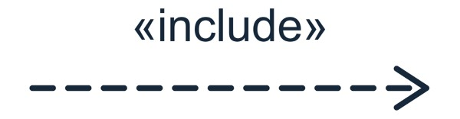 | Dashed open arrow from the base to required supporting behaviour.
Extend | 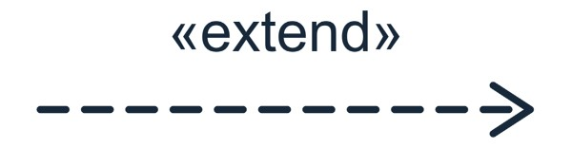 | Dashed open arrow from optional behaviour to the base use case.
Generalization | 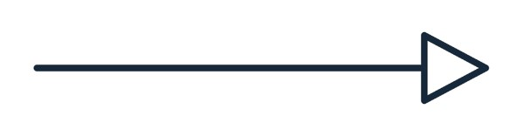 | Solid line with a hollow triangle pointing to the general actor or use case.

Part A QU Print Shop - Guided practice

Work through A.1 to A.4 with the instructor (35 minutes).

A.1 Recall the system and identify actors
Yellow highlighting marks the additions for Lab 5.
The QU Print Shop provides document printing services to students and staff members. A user uploads a document and selects the printing options: the number of copies, colour or black-and-white printing, and single- or double-sided printing.
Before accepting a print job, the Print Shop checks whether the user has sufficient credit. Credit balances are maintained by the Print Account System (PAS), a commercial package already operated by the university. The Print Shop does not maintain balances or collect money. If sufficient credit is available, the job is accepted and queued for printing; otherwise, the request is rejected and the user is informed.
Users may revise the printing options of a queued job. Before accepting either a new job or revised options, the Print Shop checks with PAS whether the user has sufficient credit for the resulting printing cost.
The Print Shop keeps a record of each accepted job, including who submitted it, the selected printing options, and its status: queued, printed or collected. Accepted, queued jobs are processed automatically. After printing a job, the Print Shop marks it as printed and sends charge advice to PAS, which processes the charge. The Print Shop also notifies the user that the printed document is ready for collection.
When collecting the printed document, the user submits a collection request, and the Print Shop records the job as collected. The user may also request a collection receipt, which the Print Shop issues once collection has been recorded.
Staff members can additionally request a summary of their own print jobs. This summary is produced from the Print Shop’s job records and includes only the requesting staff member’s jobs.

A.2 Identify actors and goals before drawing
Work through these five steps together. Use evidence from A.1 and state the result of each interaction before choosing a use case name.

Step 1 Establish the boundary
The Print Shop manages jobs, printing, notifications and collection records. PAS maintains credit balances and processes charges. Keep PAS outside the Print Shop boundary; sending charge advice is the Print Shop’s responsibility.

Step 2 Identify who interacts with the system
Actor | Actor type | Interaction with the Print Shop
User | Primary | Represents the common role of students and staff: submits print requests, collects printed documents and receives notifications.
Student | Primary | Specializes User and inherits its interactions.
Staff member | Primary | Specializes User and inherits its interactions. Also requests a summary of their own print jobs.
PAS | Secondary | Provides credit-check results and receives charge advice. It is an external supporting system.

Step 3 Identify a purpose and a successful outcome
For each interaction, ask: What is its purpose, and what will be true when it succeeds? Name use cases with a verb and an object.
Use case ID: UC001. UC stands for Use Case; the three-digit number is a stable identifier, not an execution order. Keep IDs consistent across the inventory, diagram and later specifications.
Use case ID | Use case | Successful outcome
UC001 | Submit print job | A job with sufficient credit is recorded and queued with its document and options.
UC007 | Revise queued print job | Revised printing options are saved for the queued job after sufficient credit is confirmed.
UC002 | Process print job | The job is printed and marked printed; charge advice and a ready notification are sent.
UC003 | Collect printed document | Collection is recorded and the job is marked collected.
UC004 | Issue collection receipt | A requested receipt is issued after collection is recorded.
UC005 | Request own print-job summary | Only the requesting staff member’s jobs appear in the summary.
UC006 | Check sufficient credit | PAS confirms that available credit covers the resulting printing cost.

Step 4 Choose the right level of detail
- Uploading a document and selecting options are steps within UC001. Sending charge advice and notifying the user remain steps within UC002.
- UC002 runs automatically for accepted, queued jobs. User is associated with UC002 because they receive the ready notification, not because they start processing.
- UC006 is supporting behaviour shared by UC001 and UC007. Extracting it avoids describing the same credit check twice. Not every required step needs a separate oval.
- Submission ends with a queued job; processing ends with a printed job. Their order alone does not justify an include relationship.

Step 5 Select and justify relationships
Relationship | Print Shop example | Reason
include | UC001 and UC007 include UC006. | Both submission and revision require the same credit check. Each include arrow points to UC006.
extend | UC004 extends UC003. | Receipt condition: [receipt requested]. Extension point:  collection recorded. Collection can finish without a receipt.
generalization | Student and Staff member specialize User. | Both inherit User interactions. Only Staff member participates in UC005.

A.3 Draw the use case diagram
- In Visual Paradigm, choose Diagram > New > Use Case Diagram.

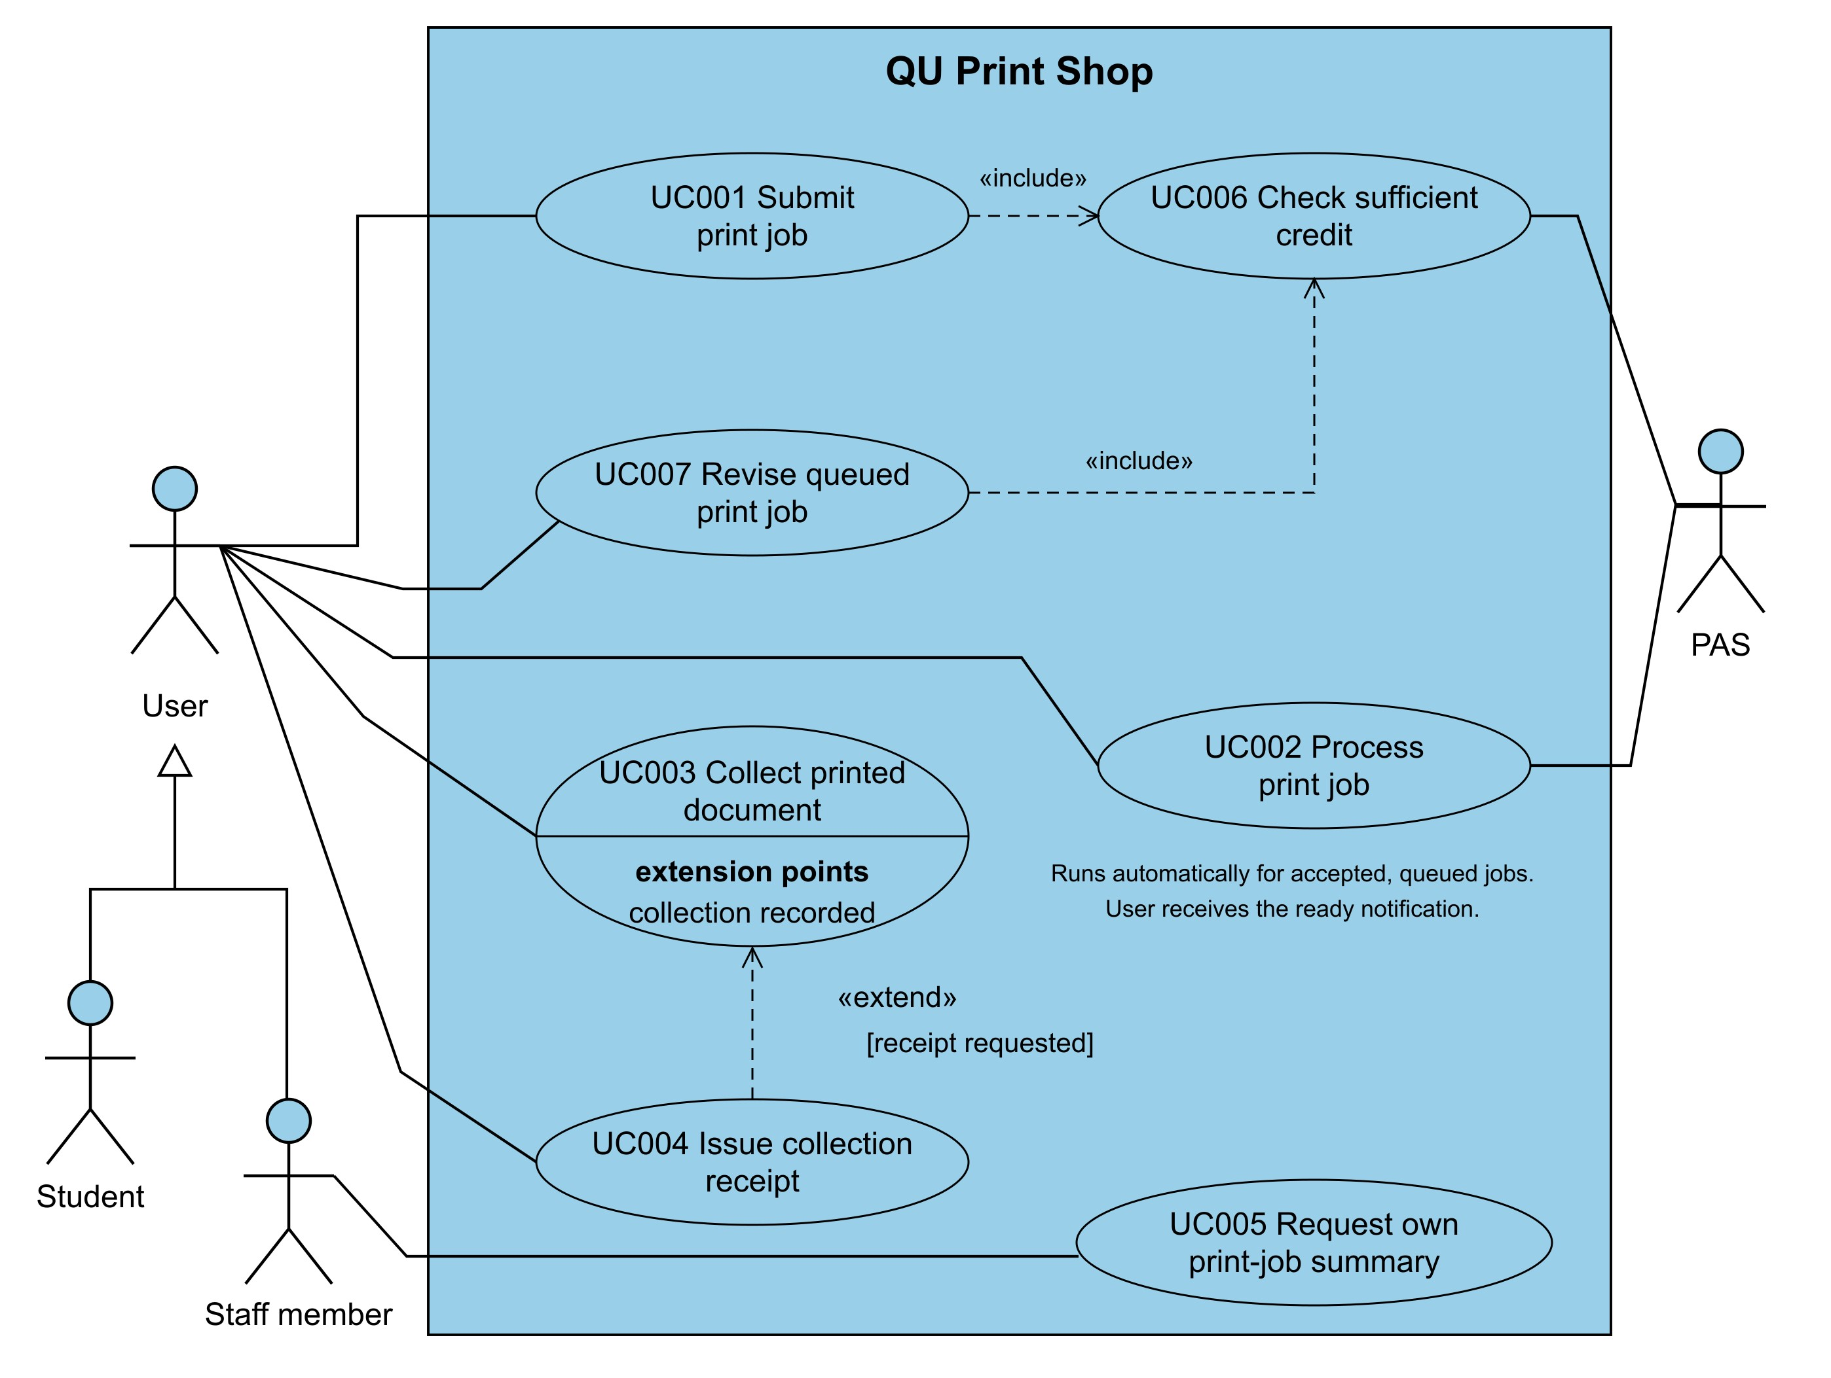
Figure 1 QU Print Shop Use Case Diagram
A.4 Review the diagram
- Why is User associated with automatic processing (UC002)? Can collection finish without a receipt?

Part B All Phones Shop

Individual assessment. Use the APS case from Lab 3. You may discuss ideas, but create and explain your own model. Use earlier diagrams to check scope, not to copy a list of use cases.

B1 Define the system boundary and identify actors - 10 minutes
- Write a boundary statement in two or three sentences. List actor roles and support each with an interaction from the case.
- Explain individual and corporate clients, and how buying and selling roles relate to them.
- Keep PoB responsible for payments and financial accounts; APS handles registration, sales and invoices. Login is outside scope. Do not invent staff roles or external systems.
All Phones Shop (APS) manages client registration, phone listings, buying and selling, auctions, invoices, and sale cancellation. PoB is an external system responsible for client financial accounts and payments. Login operations are outside the scope of APS.
Actor | Actor type | Interaction with APS
Client | Primary | General role for APS clients. Registers, buys items, sells items, places bids, and receives invoices.
Individual Client | Primary | Specializes Client and inherits Client interactions. Can create a registration but cannot remove a registration.
Corporate Client | Primary | Specializes Client and inherits Client interactions. Can create and remove a registration.
PoB | Secondary | External supporting system. Manages client financial accounts and payments; receives registration and penalty advice from APS and informs APS when invoices are paid.

B2 Build the use case inventory - 25 minutes
Use verb–object names and IDs UC001, UC002 and so on. Start a separate sequence for the APS model. Complete this table, adding rows as needed.

Use case ID and name | Participating actors | Successful outcome | Case evidence
UC001 Register client | Client, PoB | A new client registration is created with a unique registration number and PoB is informed. | Client provides name and address; APS creates the registration, assigns a unique registration number, and advises PoB.
UC002 Remove registration | Corporate Client, PoB | The registration is removed if there is no unpaid invoice, and PoB is informed. | Only corporate clients can remove a registration; APS checks for unpaid invoices before removal.
UC003 List item for sale | Client | The item information is recorded, an item ID is assigned, and the item is prepared for display. | Client selects the phone type, provides item details, and chooses auction or fixed-price sale.
UC004 Approve display image | Client | An approved display image is attached and the item is included in the product catalog. | APS creates a display image and asks the seller to approve it; if rejected, another image is created.
UC005 Withdraw listed item | Client, PoB | The item is removed before sale and penalty advice is sent to PoB. | Client may remove an displayed item before sale; APS charges a penalty and advises PoB.
UC006 Purchase fixed-price items | Client | The shopping basket is saved, checkout is completed, and the items are marked sold and removed from the catalog. | Client selects fixed-price items, APS creates a basket, and the client checks out.
UC007 Place bid | Client | A valid bid higher than the previous bid is recorded with the client's registration. | Client may bid before the auction ends; each bid must be greater than the last offered bid.
UC008 Complete auction | Client | The highest bidder is notified as the winner and the item is marked sold and removed from the catalog. | When the auction ends, the client with the last bid becomes the winner.
UC009 Create invoice | Client | The confirmed invoice is attached to the client registration with status unpaid. | APS prepares an invoice for either type of sale and the client confirms it.
UC010 Record invoice payment | PoB | The correct invoice is found and its status is changed to paid. | PoB informs APS using the client registration number and invoice number after payment.
UC011 Handle overdue sale | PoB | The penalty is advised to PoB and the unpaid sale is cancelled. | If payment is not made within 7 days, APS charges a 10% penalty and cancels the sale.

Check coverage of:
- Registration and removal; listings, image approval and withdrawal.
- Fixed-price purchases; bidding and auction completion.
- Invoicing, payment notifications and overdue sales.
For auction behaviour, distinguish placing a bid from the later result. Identify the trigger and participants; time passing does not itself justify a Clock actor. Record unresolved questions as assumptions for instructor review.

B3 Draw and refine the diagram - 35 minutes
- Create APS Use Cases in Visual Paradigm. Put use cases inside an All Phones Shop boundary and actors outside. Match the inventory’s IDs and names.
- Save an initial draft, then refine it. Connect actors only where they participate. Keep business rules in notes; omit DFD stores and sequence arrows.
- Record one decision for each relationship type below. A justified decision to omit a type is acceptable; no number of connectors is required.
Type | Candidate elements | Use or omit and why
include | UC003 List item for sale and UC004 Approve display image | Use. UC003 includes UC004 because approving the generated display image is required before the item can be added to the product catalog.
extend | UC011 Handle overdue sale and UC009 Create invoice | Use. UC011 extends UC009 when [invoice unpaid for 7 days], at the extension point "invoice remains unpaid". UC009 can finish normally without UC011 if the invoice is paid on time.
generalization | Individual Client, Corporate Client, and Client | Use. Individual Client and Corporate Client specialize Client and inherit its buying and selling interactions. Only Corporate Client has the additional permission to remove a registration.
- Include: identify the required behaviour.
- Extend: state the condition and extension point; explain why the base can stand alone.
- Generalization: check inherited behaviour and permissions. Save the refined model.
B4 Review and improve the model - 20 minutes.
Exchange diagrams with a classmate and check:
- Boundary and actors: external roles and interactions are supported by the case.
- Coverage: meaningful goals cover the B2 areas.
- Relationships: types, arrow directions and inherited permissions are correct.
- Consistency: names and IDs match the inventory; connections are readable.
Record one strength, one specific improvement and the change you made. Resolve uncertain choices with the instructor and update both the diagram and inventory.
Strengths :
- Explict uml justifications clear logic provided for using or omitting relationsships like include and extend and generalization
- Structured mapping organizes use cases by id primary actors outcomes and business rules systematically
Weakness:
- Unclear actor roles blends primarty and suppoting actors together in the actor column without distinguishing responsibilities
Change made:
- The actor descriptions were clarified to explicitly distinguish primary client actors from PoB as a secondary supporting actor.

Submission requirements
15 minutes. Submit these three files to your-repo/05-use-cases/ using the individual repository workflow from Lab 4. Part A is not submitted.
File | Required contents
lab05-solution.docx | Name and student ID; B1 boundary and actors; B2 inventory; final diagram and B3 decisions; B4 review and revision; B5 outcome; assumptions.
aps-use-cases.png | Readable export of the final APS diagram.
aps-use-cases.vpp | Editable Visual Paradigm project containing both initial and final diagrams.

Commit and push all three files, then check that they open from the repository. Bring your final diagram and inventory to Lab 6.

Assessment criteria (10 points)
Criterion | Points
Correct boundary, supported actors and appropriate role permissions | 2
Meaningful use cases, case coverage and evidence in the inventory | 3
Correct relationships and justified decisions to use or omit them | 2
Correct notation, readability and consistent names and IDs | 1
Peer feedback acted on and a clear successful outcome for Lab 6 | 1
Complete submission in the required formats | 1

Further reading
Visual Paradigm use case diagram guide
OMG UML 2.5.1 Section 18 Use Cases

